Step 1: Attack the FTP Service (Before Defense)

Goal: Prove the service is vulnerable.

1.1 Launch Metasploit on Kali

bash

msfconsole

Screenshot: Take a screenshot of Metasploit launching.

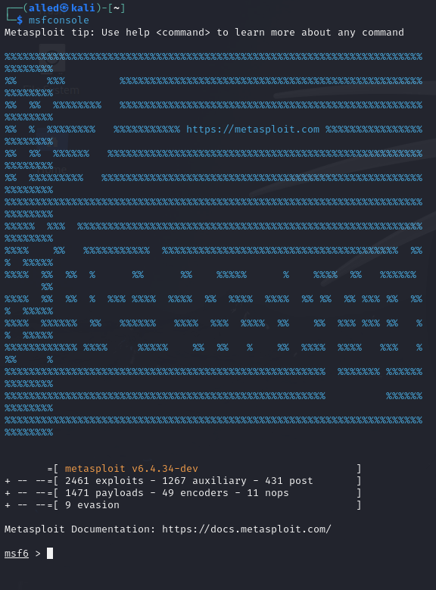

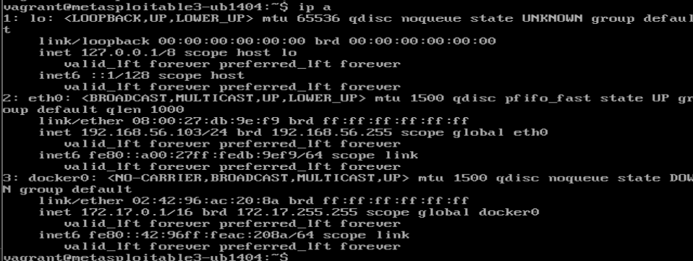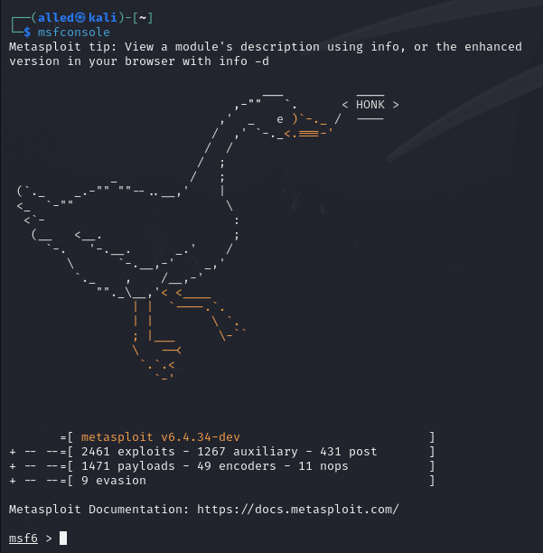

NEW TRY:  
  
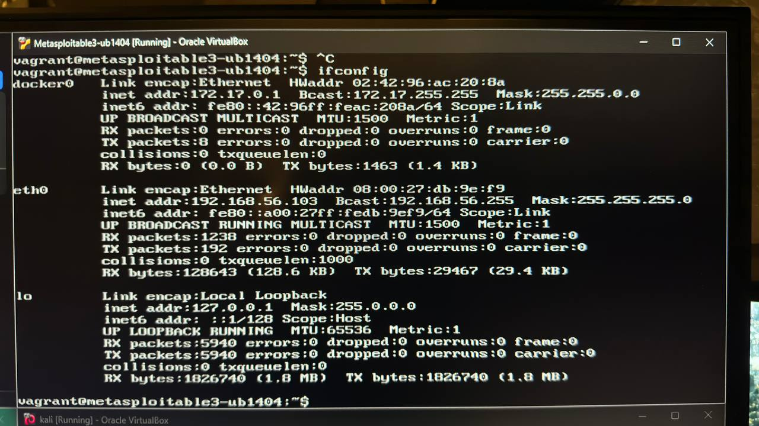



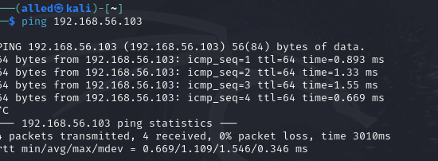

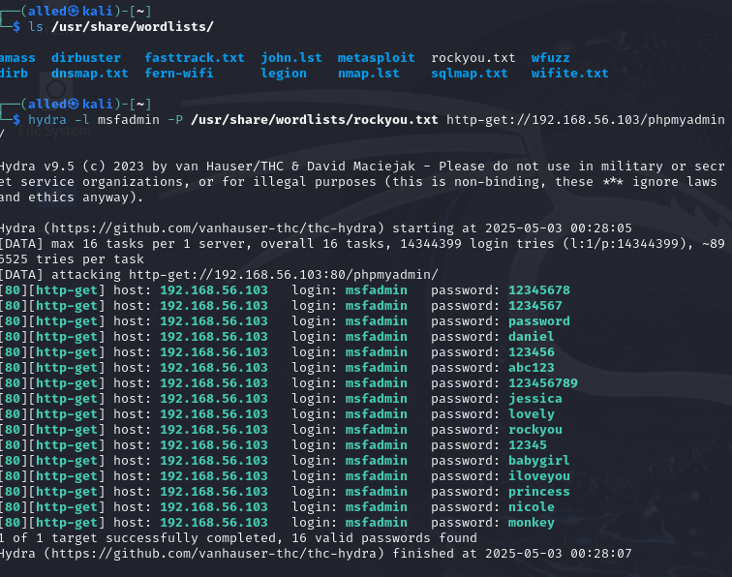

Before:

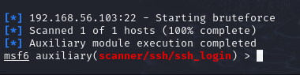

Failed :

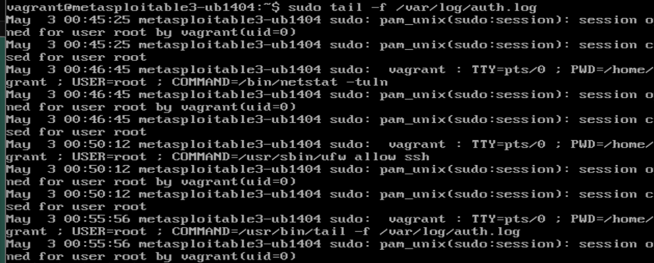

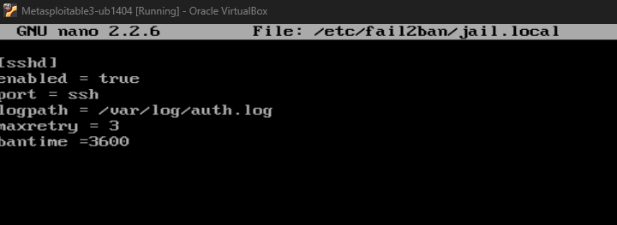



Now:  
  
before defense :disable

